Warranty Coverage Notice Instructions

Please read this guide first before formatting your own branded notice for clients
Thank you for downloading the sample ScalePad Warranty Coverage Notice / Risk Acknowledgement Form. This document is customizable in Google Docs and Microsoft Word.

Edit Fields and Body Text to Reflect Your Offering
In areas highlighted, please insert the appropriate data (example below):

You will also need to edit the text so that it aligns with your company’s policies and offering. This document should be revised to reflect your own hardware standards, and what you’ve contracted to deliver to your clients in your own master services agreement. Make any changes you like to make it work for your business.

Add Company Branding
We recommend adding your company branding by replacing the placeholder logo, as demonstrated below.
- Right click on the image and select “Replace image” and add a jpg or png file
- File size recommended is 150px - 200px wide.

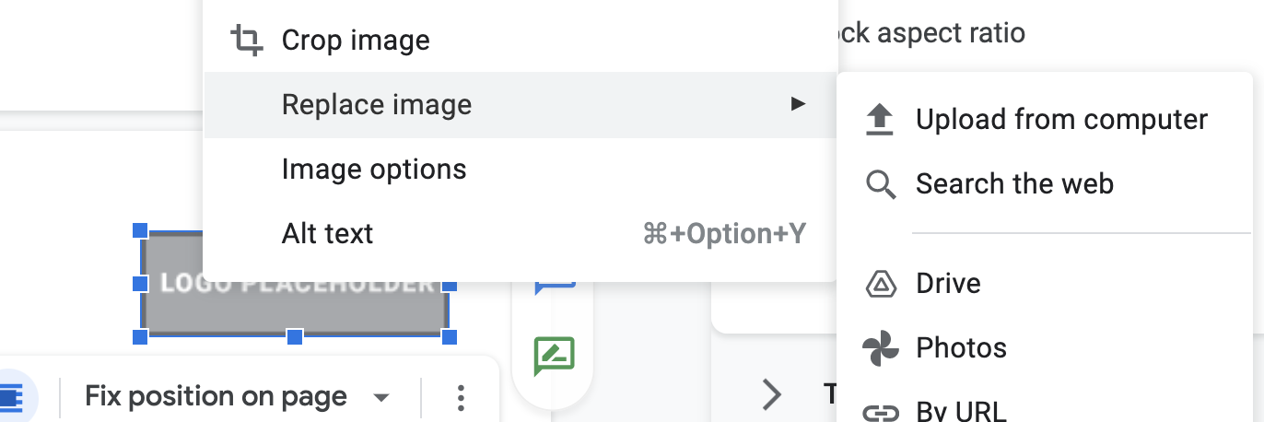

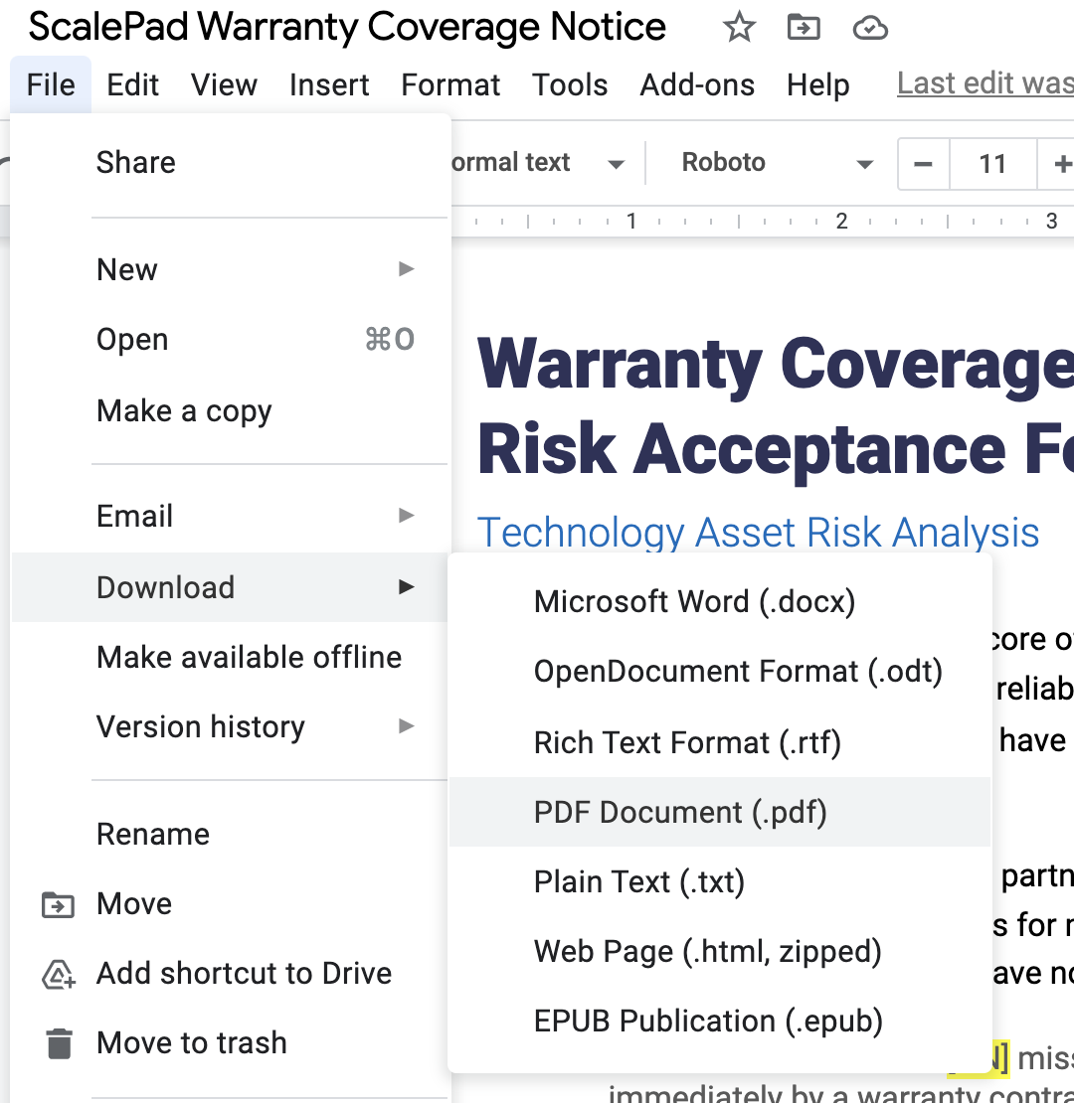
Export document
We recommend exporting this document as a PDF once completed to prevent further edits, and to allow easy printing for your clients. See example adjacent.
Select File > Download > PDF document

Warranty Coverage Notice /
Risk Acknowledgement Form

Technology Asset Risk Analysis
Risk management and trust are the core of our relationship with your organization. As part of our commitment to providing you with a reliable, high quality information technology infrastructure, we have identified a number of IT assets that have aged out and are no longer covered by their original manufacturer’s warranty.
In our role as your IT partner, [your company’s name] is committed to helping you understand your level of risk and providing you with options for minimizing it. Several systems in your organization are at significant risk due to the fact they have no hardware warranty at this time.
- Our team has identified [NN] mission-critical infrastructure systems that should be covered immediately by a warranty contract.
- In addition, we have identified [NNN] workstations that are eligible for an additional year of warranty, which we highly recommend.
Our backup solutions ensure that mission-critical data is protected, but during failure of underlying equipment, the system still needs to be repaired and restored back into service. Our service levels to your organization are guaranteed as per our managed services agreement; however, we are vulnerable to the availability of parts if equipment fails. Our ability to repair aging systems will be limited because locating parts in a reasonable time frame is challenging, which can result in additional downtime in the event of a failure. Please note that we do not inventory spare parts for most servers or workstations.
A complete summary of all your IT assets has been included as a PDF for your review.

Short-term Solution
Coverage for recommended systems can be obtained and activated within one business day. Initial coverage will be for one year, and we will plan to renew it as needed (see below).
In the event a covered system fails, our service level stays intact, and all repairs are covered as part of your managed services agreement.

Long-term Planning
We can also help you roadmap your IT infrastructure for the future by offering strategic recommendations, including cloud migration, consolidation, retirement of unneeded deprecated assets, or any combination thereof. In the interim, we must nonetheless ensure you have gap coverage as we work with you to plan and execute your technology roadmap.
Outside the cases identified here, the systems are currently performing satisfactorily, so replacing them is not necessary as long as they continue to meet your needs.

Asset List

Manufacturer | Model # | Warranty Expiration

Recommended Investment

Warranty Coverage Extension / Renewal | Cost

Benefits & What’s Included
Limited Investment: Inexpensive coverage vs. asset replacement/project services
Risk Management: Coverage of all important assets, including all parts and labor covered under your managed services agreement.
Coverage is intended to protect your IT assets from equipment failures and to get it repaired and restored back into service by providing for maintenance services. Not all risks are covered; there are specified exclusions from warranty coverage that will be included in the terms of service. A non-exhaustive sample list of these exclusions includes abuse or misuse (servers are not skateboard ramps), transportation (equipment is damaged in an unauthorized move), and coffee spill-related accidents (use your imagination).

Client Approval / Risk Acknowledgement
I approve coverage as recommended

I decline coverage & accept outlined risk

Print Name

Title

Company / Organization Name

Signature

_
Initials for Decline

______ I acknowledge that any work on out-of-warranty systems is billable on a time & materials basis
______ I acknowledge that parts may not be available for out-of-warranty systems
______ I acknowledge that a failure of out-of-warranty systems may result in lengthy downtime
______ I acknowledge that standard service levels cannot be guaranteed on out-of-warranty systems

